Republicans have dramatically shifted their views of the US economy since the election 

The way Republicans view the economy has undergone a dramatic shift in the week since Donald Trump was elected president of the United States.

Gallup’s Economic Confidence Index, based on an average of how Americans view current economic conditions, registered a large shift among self-identified Republicans over a week time period following Election Day.

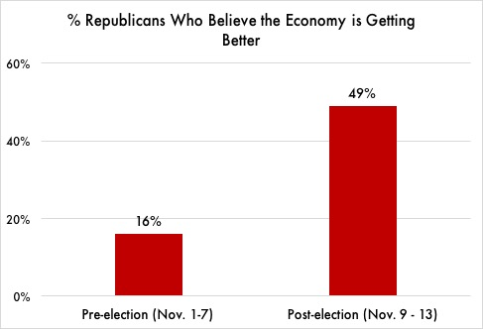“The increase in economic confidence mostly stems from Republicans’ more positive views after Republican Donald Trump won the election,” said the release from Gallup. “Republicans have had a dismal view of the economy — especially of its future direction — during Democratic President Barack Obama’s two terms.”

In fact, the proportion of Republicans saying the economy is getting better improved from 16% in the preelection period to 49% after Trump was elected.

*Republicans became more optimistic about the economy immediately following Trump’s election. Source: Gallup Polls, Nov. 1-13, 2016.*

It is important to note that despite the huge swing in Gallup’s polling, economic conditions – including rates of unemployment, inflation, and wage growth – have not changed over the past few weeks.

“Republicans are out of their minds if they think the economy is suddenly doing better because of Trump,” said Susan Thomas, a retired schoolteacher from Harrisburg, PA who voted for Hillary Clinton in 2016. “He’s just benefiting from the work Obama did. Anyone who can’t see that is delusional.”

President Trump has frequently touted the economy’s performance under his administration, often tweeting out reports of the stock market hitting new highs. The White House has also balked at suggestions that former President Obama is responsible for the current state of the economy.